TASK – 3

Goal:
Create a small Flask-based application (to do app, notes app, contact form, etc.).

Requirements:
- Flask routing & templates
- CRUD operations (optional)
- Bootstrap UI

Deliverables:
- Source code on GitHub
- Hosted version (Render, PythonAnywhere) optional

Idea of execution:
flask_notes_app/
│
├── app.py # Main Flask application logic
└── templates/ # Folder for HTML templates
├── base.html # Main layout with Bootstrap CDN
├── index.html # Homepage (View and Create Notes)
└── edit.html # Edit Note page
app.py
from flask import Flask, render_template, request, redirect, url_for

app = Flask(__name__)

# In-memory database for demonstration purposes
# Structure: {id: {"title": str, "content": str} }
notes = {
1: {"title": "Buy Groceries", "content": "Milk, Eggs, Bread, and Coffee."},
2: {"title": "Flask Project", "content": "Finish building this awesome CRUD notes application!"}
}
next_id = 3

@app.route('/')
def index():
# READ: Display all notes on the homepage
return render_template('index.html', notes=notes)

@app.route('/create', methods=['POST'])
def create():
global next_id
# CREATE: Grab form data and add it to our dictionary
title = request.form.get('title')
content = request.form.get('content')

if title or content:
notes[next_id] = {"title": title, "content": content}
next_id += 1

return redirect(url_for('index'))

@app.route('/edit/<int:note_id>', methods=['GET', 'POST'])
def edit(note_id):
note = notes.get(note_id)
if not note:
return "Note not found", 404

if request.method == 'POST':
# UPDATE: Modify the existing note details
note['title'] = request.form.get('title')
note['content'] = request.form.get('content')
return redirect(url_for('index'))

return render_template('edit.html', note=note, note_id=note_id)

@app.route('/delete/<int:note_id>')
def delete(note_id):
# DELETE: Remove the note from the dictionary
if note_id in notes:
del notes[note_id]
return redirect(url_for('index'))
if __name__ == '__main__':
app.run(debug=True)
base.html
<!DOCTYPE html>
<html lang="en">
<head>
<meta charset="UTF-8">
<meta name="viewport" content="width=device-width, initial-scale=1.0">
<title>Flask Quick Notes</title>
<link href="https://cdn.jsdelivr.net/npm/bootstrap@2.5.3/dist/css/bootstrap.min.css" rel="stylesheet">
</head>
<body class="bg-light">

<nav class="navbar navbar-dark bg-dark mb-4">
<div class="container">
<a class="navbar-brand font-weight-bold" href="/">📝 Flask Quick Notes</a>
</div>
</nav>

<div class="container">
{% block content %}
{% endblock %}
</div>

<script src="https://cdn.jsdelivr.net/npm/bootstrap@5.3.3/dist/js/bootstrap.bundle.min.js"></script>
</body>
</html>
index.html
{% extends 'base.html' %}
{% block content %}
<div class="row">
<div class="col-md-4 mb-4">
<div class="card shadow-sm">
<div class="card-body">
<h5 class="card-title mb-3">Add a New Note</h5>
<form action="/create" method="POST">
<div class="mb-3">
<label for="title" class="form-label">Title</label>
<input type="text" class="form-control" id="title" name="title" required>
</div>
<div class="mb-3">
<label for="content" class="form-label">Content</label>
<textarea class="form-control" id="content" name="content" rows="4" required></textarea>
</div>
<button type="submit" class="btn btn-primary w-100">Save Note</button>
</form>
</div>
</div>
</div>

<div class="col-md-8">
<h3 class="mb-3">My Notes</h3>
{% if not notes %}
<div class="alert alert-info">No notes available. Add one to get started!</div>
{% else %}
<div class="row">
{% for id, note in notes.items() %}
<div class="col-md-6 mb-3">
<div class="card h-100 shadow-sm">
<div class="card-body d-flex flex-column">
<h5 class="card-title text-truncate">{{ note.title }}</h5>
<p class="card-text text-muted flex-grow-1" style="white-space: pre-line;">{{ note.content }}</p>
<div class="mt-3 d-flex justify-content-between">
<a href="/edit/{{ id }}" class="btn btn-sm btn-outline-secondary">Edit</a>
<a href="/delete/{{ id }}" class="btn btn-sm btn-outline-danger" onclick="return confirm('Are you sure?')">Delete</a>
</div>
</div>
</div>
</div>
{% endfor %}
</div>
{% endif %}
</div>
</div>
{% endblock %}

edit.html
{% extends 'base.html' %}
{% block content %}
<div class="row justify-content-center">
<div class="col-md-6">
<div class="card shadow-sm">
<div class="card-body">
<h4 class="card-title mb-4">Edit Note</h4>
<form action="/edit/{{ note_id }}" method="POST">
<div class="mb-3">
<label for="title" class="form-label">Title</label>
<input type="text" class="form-control" id="title" name="title" value="{{ note.title }}" required>
</div>
<div class="mb-3">
<label for="content" class="form-label">Content</label>
<textarea class="form-control" id="content" name="content" rows="5" required>{{ note.content }}</textarea>
</div>
<div class="d-flex justify-content-between">
<a href="/" class="btn btn-light border">Cancel</a>
<button type="submit" class="btn btn-success">Update Note</button>
</div>
</form>
</div>
</div>
</div>
</div>
{% endblock

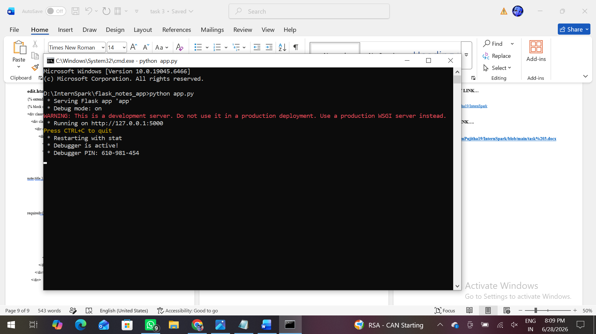

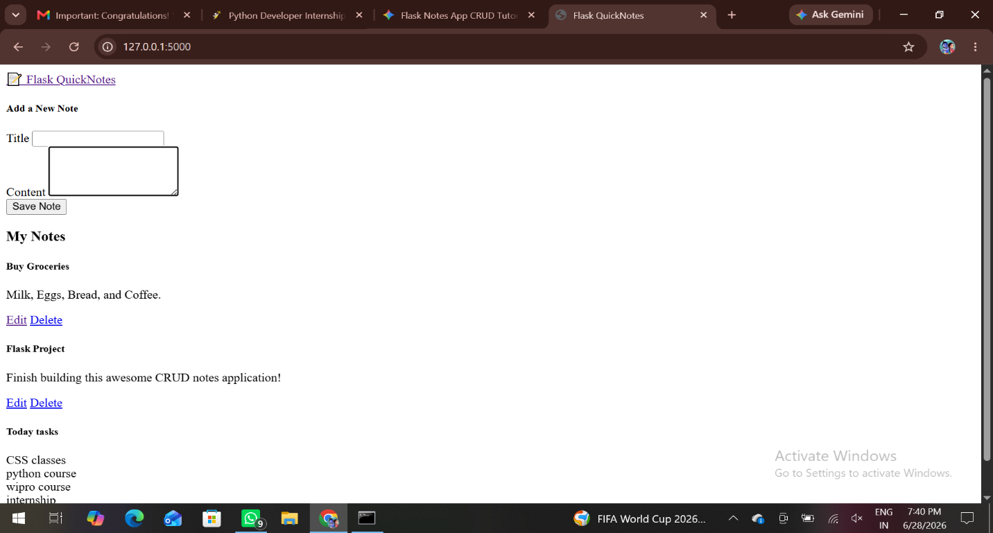

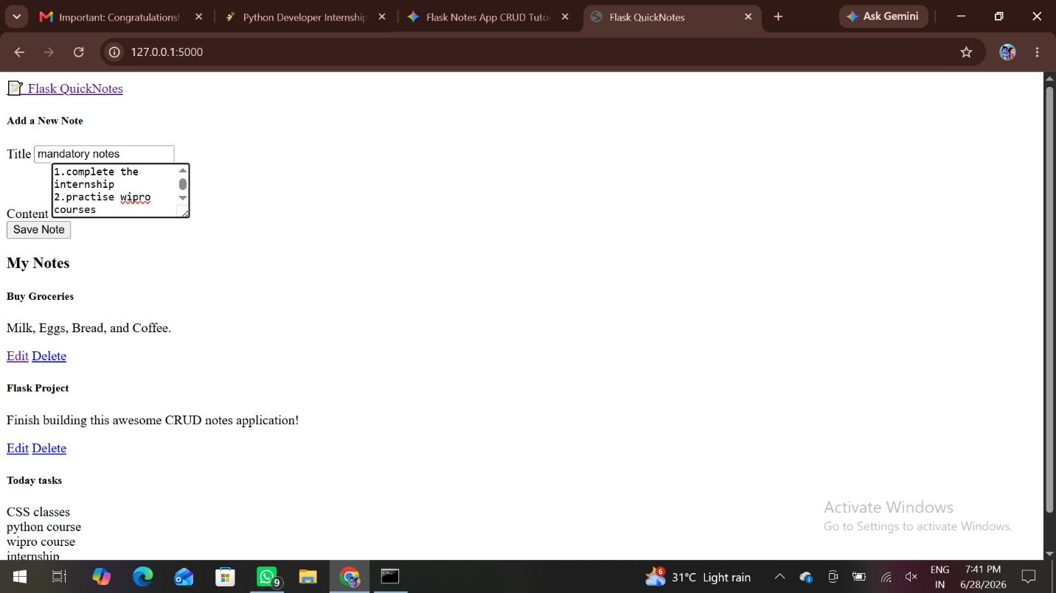

GITHUB REPOSITORY LINK…

https://github.com/DanamPujitha19/InternSpark

TASK REPOSITORY LINK….

https://github.com/DanamPujitha19/InternSpark/blob/main/task%203.docx

